Week 4

Python Logical Flow Control

Logical Flow Control – programs control flow – order that the code is executed, regulated by conditional statements loops and functions, default mode, lines of code are executed from top to bottom,

Sequential – execution happens in sequence, default mode, lines are executed from top to bottom, rarely linear or simple

**See video for more notes. These are not complete**

Selection **decision** or **branching** **statements** tests various conditions and executes instructions based on which one is true

Loop statements – while, for, range(); combined with other loops to enhance repetitive actions, uses break and else

Method = . separates it makes it a method

Attributes describe

Library object method ------research these

Argument – value passing through a function

Day 2

Modules and Libraries – code with useful features that were created by other programmers in python, reduce the amount of code that has to be written from scratch

Modules- module is a chunk of related code saved in the same file, random module generates a random number, date/time manipulates date and time data

Packages – used for creating larger applications, contain several modules, directory includes _init_.py in name



Libraries – similar to packages contains mult modules and/or packages

Frameworks – collection of modules and packages that fast track dev

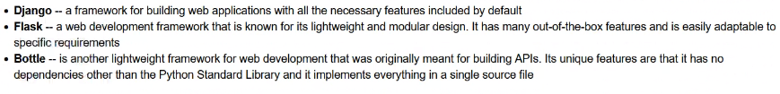

How to use them – call import function, for specific from import; mainly use specific call functions for better programming practices promotes efficiency within the code allowing for faster programs

Exception Handling

Try/except -surround a dangerous section of code that may not work with try and except, if the code works except is skipped, if the code fails the program carries out the except function not causing a traceback(try this, if it doesn’t work do this)

In except you can name a specific error to return something specifically for that error

Try – lets you test code without crashing the code

Else – executes if no errors

Finally - block lets you execute code regardless of if theres an error

Defined Functions show up green in python

Default argument - 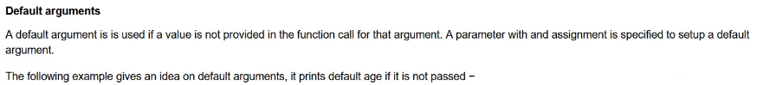

Return turns a local variable (var inside a code block) to a global variable (accessible to the rest of the code)

Scope Variables

**HOW TO CREATE A LIST USING FUNCTIONS**